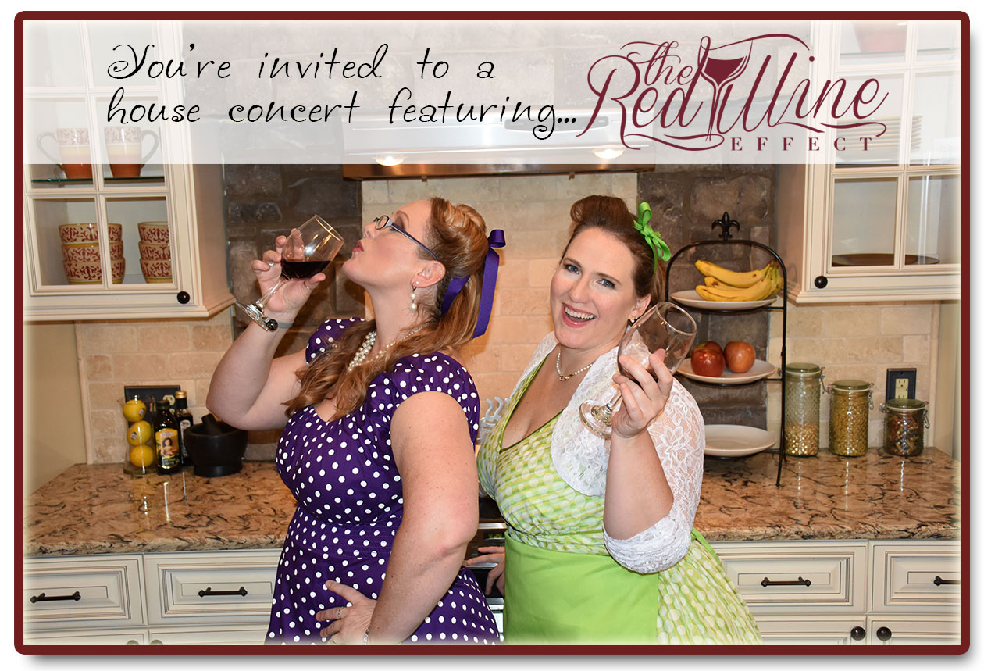

What’s a House Concert???  Well, it’s basically just what it sounds like... a concert given in someone’s living room! Usually, there is also food, drink, and merriment involved.  House Concert Etiquette  - Please no talking during the performance - think symphony rather than pub atmosphere  - Suggested donation of $10-$20 per person helps cover the artist’s travel costs and future musical endeavors | <MESSAGE FROM THE HOST>  When: <DATE/TIME>  Where: <ADDRESS>  RSVP: <EMAIL/PHONE>  What to bring:  <SOME HOSTS GO POTLUCK-STYLE AND GUESTS ARE ASKED TO BRING A SIDE/DESSERT TO SHARE>

